Revision Part 2

Measurement
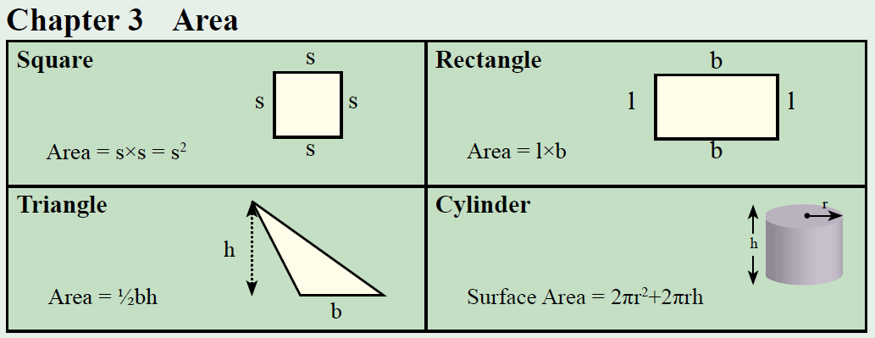
1 | 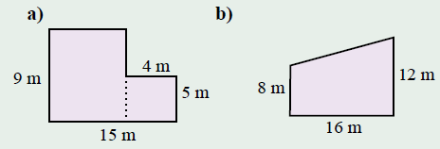
2 | Find the area of the following shapes:  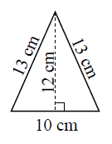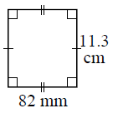
3 | 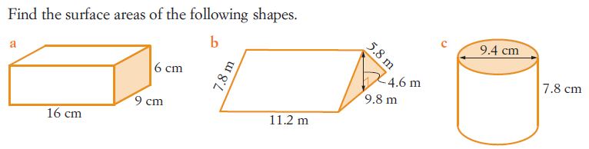
Proportion
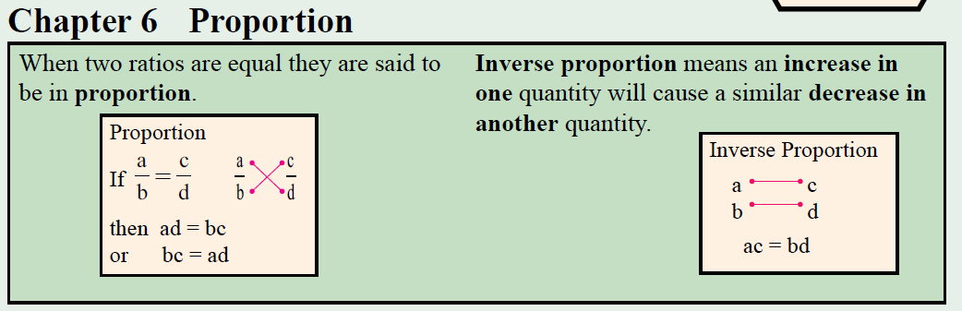
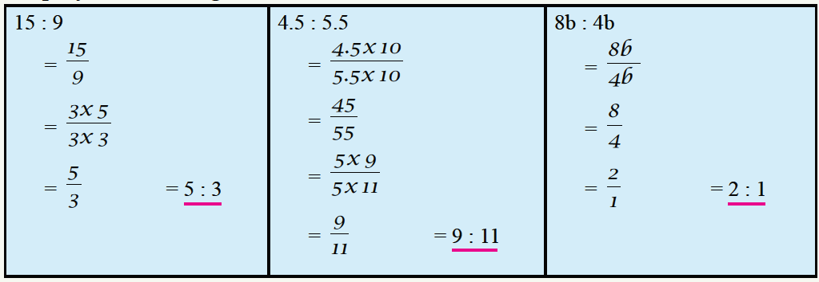
1 | 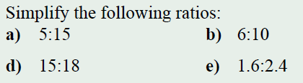
2 | 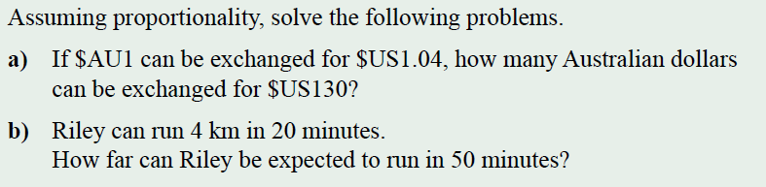
3 | 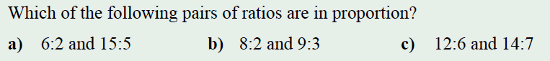
Pythagoras Theorem
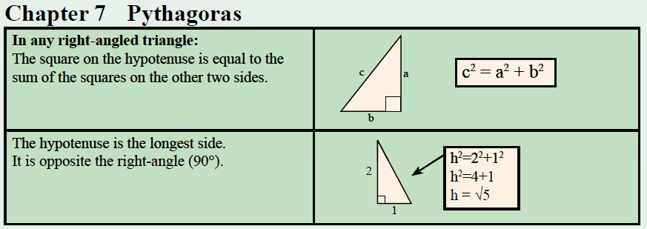
Finding Length of the Short Side  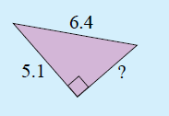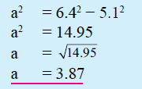 |  | Find Distance Between Points
1 | 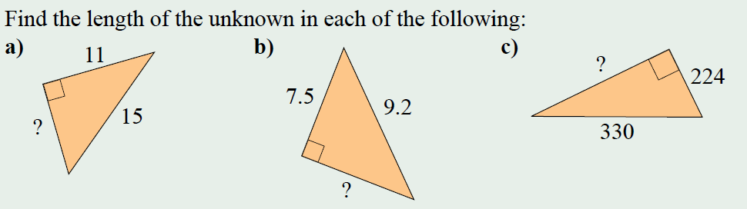
2 | 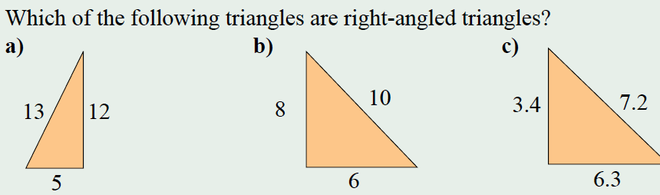
3 | 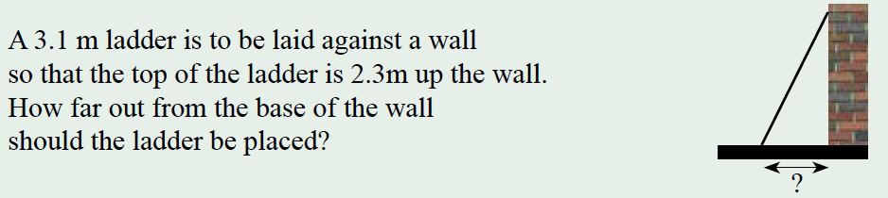
4 | Find the distance between the points

